Seethalakshmi Achi College For Women

Pallathur

Affiliated By Alagappa University

Department of Commerce

III -B.COM

**FINANCE AND ACCOUNTING WITH ZOHO BOOKS**

**FASHION HAVIN**

**Team**

**Team members**

1.V. Muthumari (Team leader)

2.U. Nanthini

3.K. Nivetha

4.S. Nivetha

**Overview : Preparation And Maintanence Of ZOHO Books For Fashion HaBen fashion Haven, an online retail store, leverages Zoho Books to manage their inventory and track sales. They can generate invoices and manage customer payments seamlessly. Zoho Books also enables them to reconcile bank transactions and generate financial reports, helping them make informed decisions about their business..**

**Fashion Haven is a Private Limited company also registered under GST in Tamil Nadu. Fashion Haven is a retailor of various lifestyle products in wholesale and retail, it has a wide range of customers (B2B & B2C) all over the state and it procures from various suppliers in the state. It operates at a Gross Profit margin of 50%.**

**Empathy map**

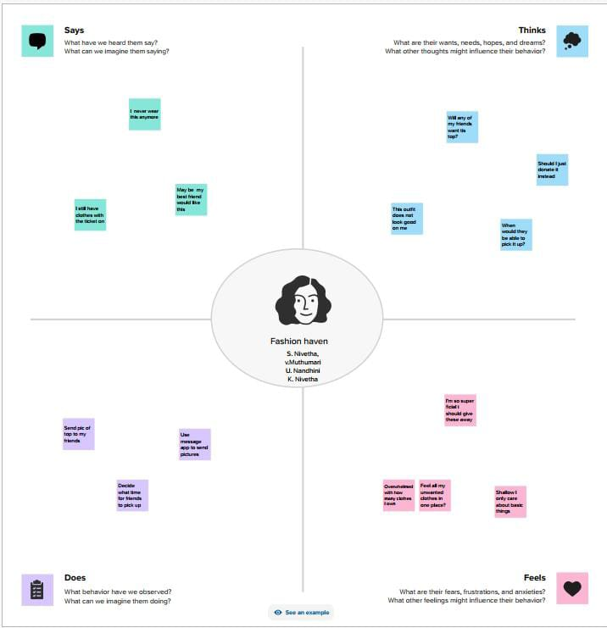

**Brainstorming and idea prioritation**

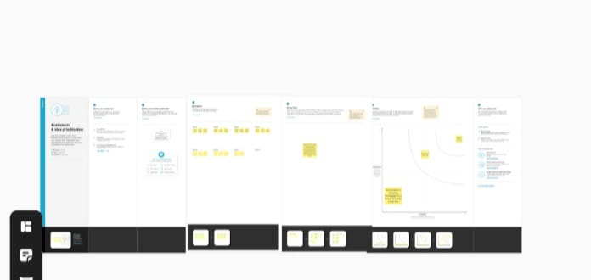

**Result:** 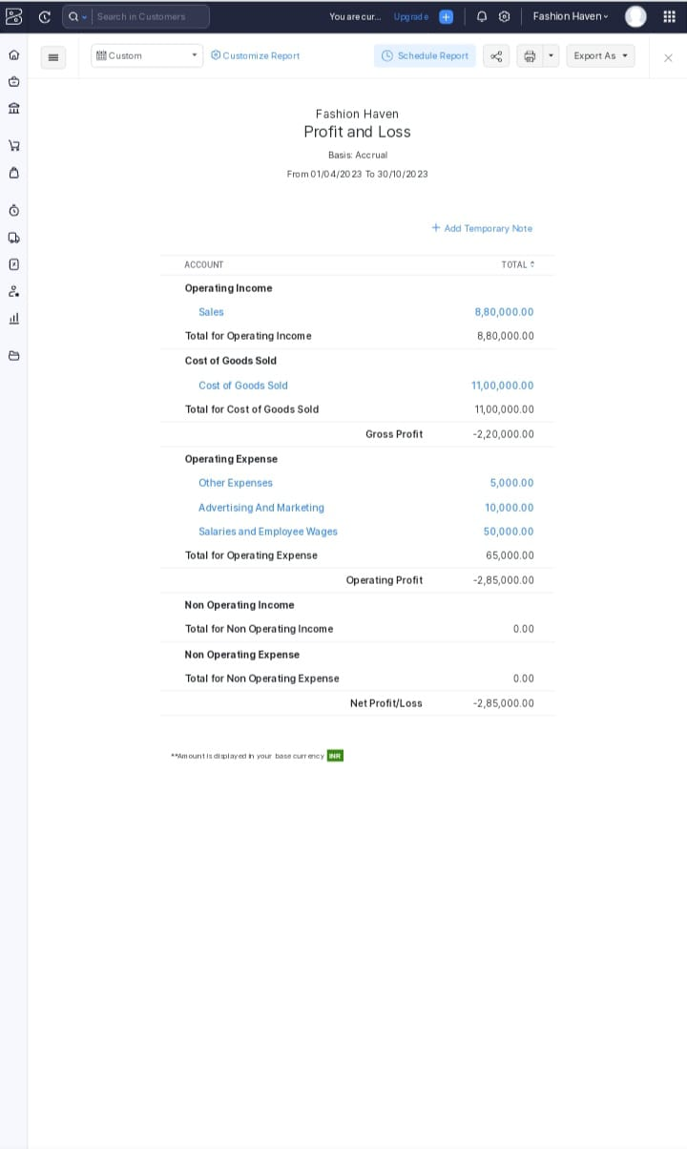

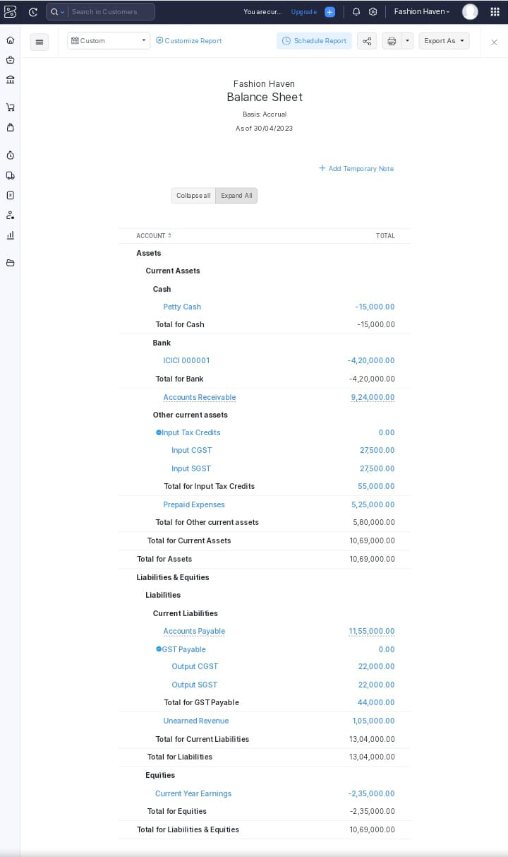

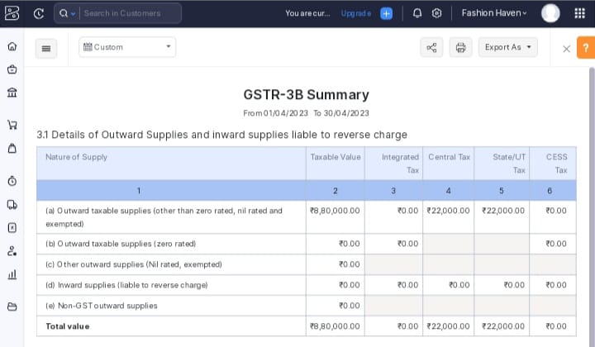

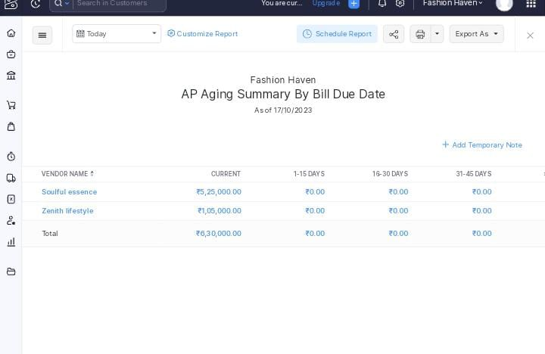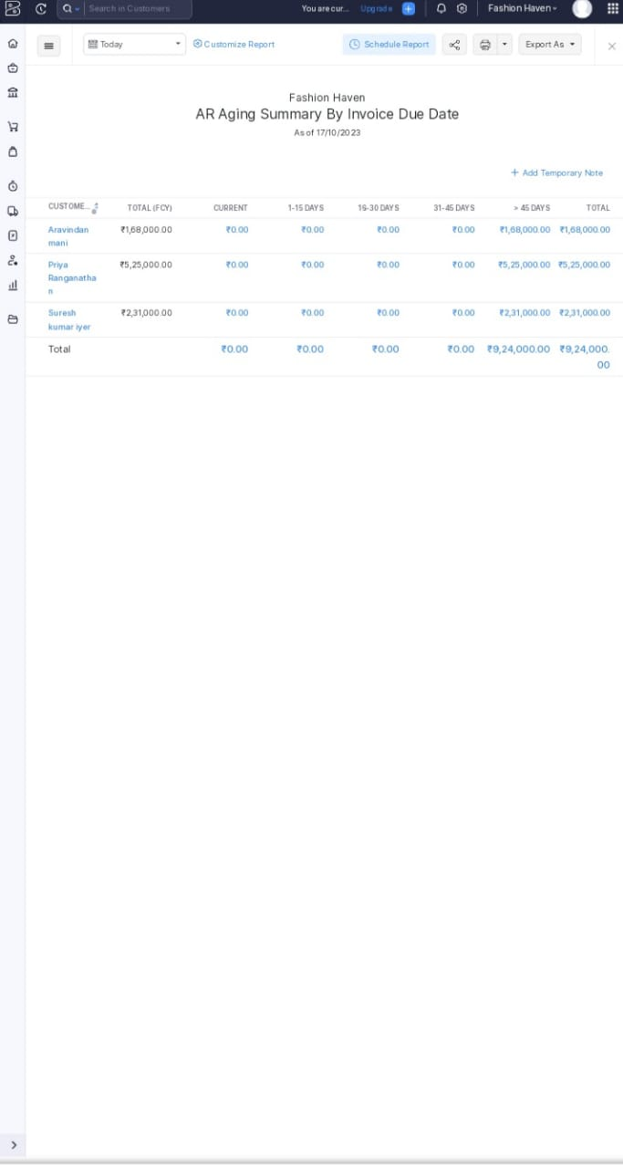

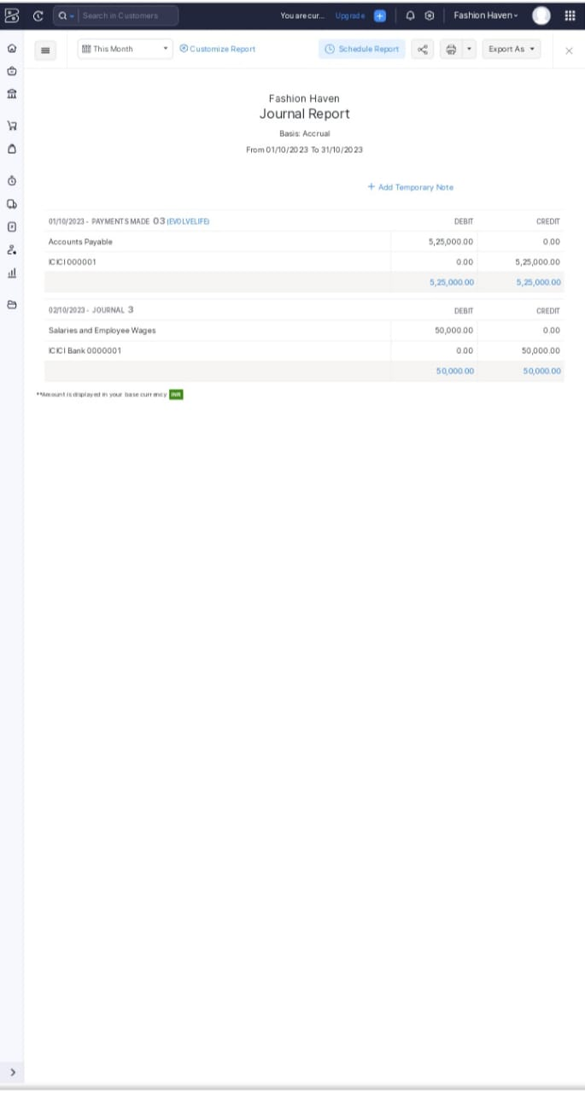**hi**

**Advantages of the proposed solution**

* Invoicing and Billing.
* Online payment.
* Expenses Tracking.
* Project Management & Timesheets
* Inventory Management
* VAT Tax Compliance
* Report Generation
* Reduce Overall Costs

**Disadvantages of the proposed solution:**

* Monthly transaction cap. One significant Zoho Books limitation is the Cap on monthly transaction
* Multiple Subscriptions for multiple businesses
* Additional users require a fee.
* Fewer integrations than competitors.
* No payroll services.
* Accounts payable limitations.

**The areas where this solution can be applied:**

Zoho Creator’s education ERP system has everything you need to completely run an educational institutions, from preschool all the way up to university. A custom school ERP built atop Creator’s intuitive low-code application development platform is a one-stop shop for all your education management needs.

From admissions to accounting, take care of everything with cloud-based applications. Build apps with minimal coding, or install prebuilt ones and customize them as needed

Contact Management. Online payments. Inventory Management. Expenses. Mobile apps.

Collaborative customer portal. GST Compliant accounting. Project Time Tracking.

Invoice Templates. Automatic Bank Feeds. Exhaustive Reports. Accounting

**Conclusions:**

Zoho Books not only helps streamline our invoicing, expenses and other business needs, but also simplifies Accounting needs to a great extent. One can even file GST returns from within it, which is a great add-on feature for free. Above all, the support is outstanding.

**Future Scope;**

Zoho Books now support recurring payments through stripe. You can receive recurring payments from your customers with payment card issued in India by either Visa or MasterCard. However, your customers’ card details will be saved only if they choose to save their cards while making payments